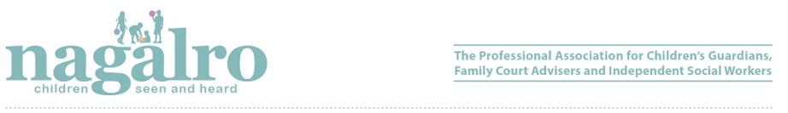

REFER AN ISW OFFER

RECEIVE A £25.00* GIFT VOUCHER OF YOUR CHOICE ~ SIMPLY BY SPREADING THE WORD.

When you refer a new Independent Social Worker for full Nagalro membership, you both win — and your VOUCHER is guaranteed once they join.

It’s a great way to support fellow ISWs, strengthen the Nagalro community, and highlight the benefits of Nagalro membership to those who are not members.

Please provide the name and e-mail address / contact details to nagalro@nagalro.com.

Full Members (UK, Northern Ireland, Isle of Man, Wales, Scotland) - £215.00 (to join in September 2026 – 31 March 2027)
Full Members (Republic of Ireland) - £240.00 (to join in September 2026 – 31 March 2027)

* The new ISW must join Nagalro. If you refer more than 1 new full member, you will receive a £25.00 gift voucher for each full member joining.

- Must be a registered social worker in UK, the Isle of Man, the Channel Islands or the Irish Republic and whose professional practice includes a significant proportion of work with children and families.

Benefits of Membership with Nagalro
- Professional indemnity and public liability insurance at highly competitive rates
- Members only reduced rates for high-quality training and conferences
- Support and legal representation with professional difficulties and complaints
- Access to the Members Advice Scheme
- Free subscription to Nagalro’s quarterly journal Seen and Heard
- Networking and peer support through the national email forum
- Easy access to professional information and updates
- Opportunity to join the online independent social work directory
- Eligible to be a member of Council
- Voting at General Meetings of Nagalro

Included in your Nagalro membership | ✔
£10m (approx. €11.5m) (professional indemnity insurance designed specifically for the needs of independent social workers | ✔
Professional indemnity insurance allows you to confidently carry out worldwide assessments¹ | ✔
£10m (approx. €11.5m) public liability insurance | ✔
£250,000 (approx. €287,000) cover for abuse and molestation² | ✔
‘Run-off’ cover included at no extra cost - no need to keep paying for membership after you have retired! | ✔
Additional cover available for your limited company³ | ✔
£5,000 (inc VAT) (approx. €5,700) towards the cost of legal representation in fitness to practice proceedings | ✔
24/7 commercial assistance and legal advice telephone helpline⁴ | ✔
Insurance provided by Hiscox an A+ rated UK insurer (5-star rating from Defaqto and rated ‘Exceptional’ by Feefo) | ✔
Swift, experienced and sympathetic claims handling | ✔

¹ Excludes regions subject to international sanctions and claims brought in the United States of America and Canada

²Included within overall £10m public liability cover

³ Subject to terms and conditions and additional fee of £50.00

⁴ Provided by ARAG Legal Expenses Insurance Company Limited

