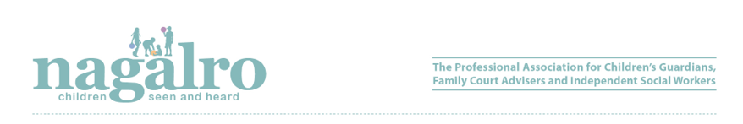

SUMMARY OF MEMBERSHIP CATEGORIES

1 April 2026 – 31 March 2027

Membership category | UK/Northern Ireland/Isle of Man/Wales/Scotland | Republic of Ireland
FULL member (Group A) | £295.00 | £320.00
FULL member (Group B) | £175.00 | £200.00
Associate member | £75.00 | £75.00
Seen and Heard | £45.00 | £45.00
Retired member | £45.00 | £45.00
Student | £25.00 (or £32.00) | £25.00 (or £32.00)

Full Members (Group A): £295.00
- Must be a registered social worker in UK, the Isle of Man, the Channel Islands or the Irish Republic and whose professional practice includes a significant proportion of work with children and families.
- Benefits:
  - Professional indemnity and public liability insurance;
  - Support and help with legal representation in the event of fitness to practice proceedings;
  - Voting at General Meetings of Nagalro;
  - Eligible to be a member of Council;
  - Preferential rates for professional training;
  - Quarterly copies of Seen and Heard;
  - Nagalro Google Group;
  - Support for professional practice issues;
  - Nagalro practice guidance notes;
  - Easy access to professional information within the ‘members only’ section of the Nagalro website;
  - Eligible to join the Nagalro Directory (subject to payment of annual fee)

Full Members (Group B) – non-insured*: £175.00

- Must be a registered social worker in UK, the Isle of Man, the Channel Islands or the Irish Republic but do not require insurance as employed by another bodies, such as, Local Authorities or Cafcass who already provide cover to their employed workforce.
- Benefits:
  - Voting at General Meetings of Nagalro;
  - Eligible to be a member of Council;
  - Preferential rates for professional training;
  - Quarterly copies of Seen and Heard;
  - Nagalro Google Group;
  - Support for professional practice issues;
  - Support and help with legal representation in the event of fitness to practice proceedings;
  - Nagalro practice guidance notes.

* Not covered by insurance for any current work, but will still have run-off cover for previous work carried out whilst a full member (Group A).

Associate Members – as defined by the Articles of Association £75.00
- Benefits:
  - Preferential rates for professional training;
  - Quarterly copies of Seen and Heard;

Seen and Heard Subscribers: £45.00
- Available to everyone
- Receive quarterly copies of Seen and Heard.

Retired Members: £45.00
- Only available to former full members of Nagalro. Retired membership is not necessary to have run-off cover for potential claims arising from pre-retirement practice. Some retired members will maintain their social work registration for a period and may be able to be more involved as a result?

NB: Nagalro members have run-off insurance automatically and without keeping their membership running for a further six years after retirement.
- Benefits:
  - Preferential rates for professional training;
  - Quarterly copies of Seen and Heard;
  - Nagalro Google Group
  - Support for professional practice issues arising from a member’s previous practice whilst a member of Nagalro.

Student Membership: £25.00 (annual fee) or £32.00 x 4 quarterly payments
Available to any undergraduate or post-graduate student of a recognised UK or Irish university studying for a social work qualification.
- Benefits:
  - Reduced subscription rate;
  - Quarterly copies of Seen and Heard;
  - Preferential rates for conference attendance and training courses;
  - Eligibility to be invited to attend Nagalro Council meeting as an observer (non-voting).
  - Reduced fee at full membership

Partnership member fees (such as AoCPP): Nagalro will offer an attractive discounted rate for partnership agencies. Also, a reduction for block bookings at conferences and training events..

Block bookings for agencies who refer groups of people = 10% discount

